AN MAHARASHTRA VIDYA PRASARAK MANDAL’S

**NUTAN COLLEGE OF ENGINEERING & RESEARCH (NCER)**

### Department of Computer Science & Engineering

**BTCOC 302**

Discrete Mathematics



|  |  |
| --- | --- |
| **Lecture Number** | **Topic to be covered (Unit 1)** |
| **Fundamental Structures and basic logic(hrs7)** | |
| 1 | SET, venn diagram cartisian product |
| 2 | Power set, cardinality and countability, propositional logic,logical connectives, Truth table |
| 3 | Normal form,validity, Predicate Logic |
| 4 | Universal and extential quantification,first order logic |
| 5 | Principle of mathematical induction, recursive definition,The division algorithm:prime number |
| 6 | The greatest common divisor, eucliden algorithm |
| 7 | The fundamental theorem of airthmatic |

: Submitted by: **Prof. T.K.zope**

|  |  |  |
| --- | --- | --- |
| **DEPARTMENT OF COMPUTER SCIENCE**  **Nutan College Of Engineering & Research, & ENGINEERING**  **Talegaon Dabhade, Pune- 410507** | | |
|  | Discrete Mathematics |  |



**Unit 1:- Fundamental Structures and basic**

**1.Set:**

Set is the most basic terms in mathematics. The theory of sets was introduces by the German mathematical G. Cantor who defines a set as collection of objects.

**Defination:**

1. A set is defined as a collection of distinct objects of the same type or class of objects.

2.The object of set are called elements or members of the sets. Object can be Numbers, Alphabets, Names etc.

For eg : A = {1,2,3,4,5}

3. Set is usually denote by the capital letter A, B, C, etc.

P={a,b,c} 1.1.Representation of a Set

Sets can be represented in two ways −

1.Roster or Tabular Form –

2. Builder form of set –

1.Roster or Tabular Form -

If a set is define by listing it’s members called tabular form.

The elements are enclosed within braces and separated by commas.

For eg− if Set P contain elements a,b,c then it’s express as  P={a,b,c}

2. Builder form of set –

When the element or member of set satisfy some properties then its called as builder set.

For eg: P = {x:x ∈ to N, x is multiple of 5}

**1.2.Set Notation:**

x ∈ A - x belongs to A or x is an element of set A.

x ∉ A - x does not belong to set A.

∅ - Empty Set

U- Universal Set.

N - The set of all natural numbers.

I - The set of all integers.

I0  - The set of all non- zero integers.

I+  - The set of all + ve integers.

**1.3. Types of Sets**

1.Equality of set:

Two sets A & B are equal if and only if A and B contain the same elements or both are elements empty.

A=B

2.Empty Set :

A set which contain no elements is called as empty set.

3.Subset:

A set ‘A’ is a subset of set ‘B’ if and only if elements of A is an elements of ‘B’

If A is subset of B then we can written it as,

A⊆ B

4.Proper Subset:

If A ⊆ B and A≠B then A is called a proper subset of B and it is Written as A ⊂ B

For eg: 1. Let A = {2, 3, 4}  
B = {2, 3, 4, 5}

A is a proper subset of B.

2. The null ∅ is a proper subset of every set.

5.Power Set:

It is denoted by P(A)

The set of all Subset of A is called power set

For eg- If A={a,b,c} then

P(A) ={∅,{a}, {b}, {c},{a,b},{b,c},{a,c},{a,b,c}}

**1.4.Operation on set**

1. Union of Sets:

Union of Sets A and B is defined to be the set of all those elements which belong to A or B or both and is denoted by A∪B.

A∪B = {x: x ∈ A or x ∈ B}

For eg- Let A = {1, 2, 3},       B= {3, 4, 5, 6}  
A∪B = {1, 2, 3, 4, 5, 6}

2. Intersection of Sets:

Intersection of two sets A and B is the set of all those elements which belong to both A and B and is denoted by A ∩ B.

A ∩ B = {x: x ∈ A and x ∈ B}

For eg- Let A = {11, 12, 13},       B = {13, 14, 15}  
A ∩ B = {13}.

3. Difference of Sets:

The difference of two sets A and B is a set of all those elements which belongs to A but do not belong to B and is denoted by A - B.

A - B = {x: x ∈ A and x ∉ B}

For eg- Let A = {1, 2, 3, 4} and B = {3, 4, 5, 6}

then A - B = {1,2}

and B - A = {5, 6}

4. Complement of a Set:

 The Complement of a Set A is a set of all those elements of the universal set which do not belong to A and is denoted by Ac.

Ac = U - A = {x: x ∈ U and x ∉ A} = {x: x ∉ A}

Let U is the set of all natural numbers.  
A = {1, 2, 3}  
Ac = {all natural numbers except 1, 2, and 3}.

**2.Venn Diagrams**

Venn diagram, invented in 1880 by John Venn, is a schematic diagram that shows all possible logical relations between different mathematical sets.

1.Union of sets

The union of sets A and B (denoted by A∪BA∪B) is the set of elements which are in A, in B, or in both A and B.

A∪B = {x: x ∈ A or x ∈ B}

eg- If A={10,11,12,13} and B = {13,14,15}, then A∪B={10,11,12,13,14,15}



**2.Intersection of set-**

The intersection of sets A and B (denoted by A∩BA∩B) is the set of elements which are in both A and B.

A∩B={x|x∈A AND x∈B}  
eg- If A={11,12,13}and

B={13,14,15}, then A∩B={13}.

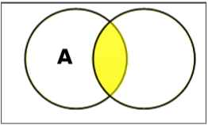

3.Set Difference/ Relative Complement  
The set difference of sets A and B (denoted by A–B) is the set of elements which are only in A but not in B.  
A−B={x|x∈A AND x∉B}.

Eg-If A={10,11,12,13} and B={13,14,15},

then (A−B)={10,11,12}

 and (B−A)={14,15}.   
Here, we can see (A−B)≠(B−A)

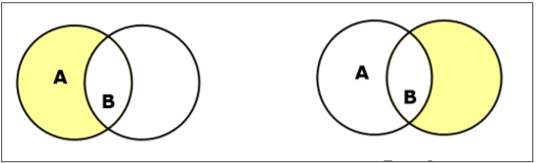

4.Complement of a Set-  
The complement of a set A (denoted by A′) is the set of elements which are not in set A.  
A′={x|x∉A}.  
A′=(U−A) where U is a universal set which contains all objects. If A={x|x belongs to set of odd integers}   
then A′={y|y does not belong to set of odd integers}

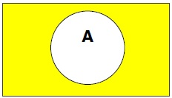

3.Cartesian Product / Cross Product

The Cartesian product of n number of sets A1,A2,…An denoted as A1×A2⋯×An  can be defined as all possible ordered pairs (x1,x2,…xn)  
where  x1 ∈ A1, x2 ∈ A2,… xn ∈ An

Eg- If we take two sets A={a,b} and B={1,2},  
The Cartesian product of A and B is written as − A×B={(a,1),(a,2),(b,1),(b,2)}  
The Cartesian product of B and A is written as − B×A={(1,a),(1,b),(2,a),(2,b)}

4.Power Set  
Power set of a set S is the set of all subsets of S including the empty set. The cardinality of a power set of a set S of cardinality n is 2n. Power set is denoted as P(S).  
Eg- For a set S={a,b,c,d}

calculate the subsets −  
Subsets with 0 elements − {∅}(the empty set)  
Subsets with 1 element − {a},{b},{c},{d}  
Subsets with 2 elements − {a,b},{a,c},{a,d},{b,c},{b,d},{c,d}  
Subsets with 3 elements − {a,b,c},{a,b,d},{a,c,d},{b,c,d}  
Subsets with 4 elements − {a,b,c,d}  
Hence, P(S)=  
{{∅},{a},{b},{c},{d},{a,b},{a,c},{a,d},{b,c},{b,d},{c,d},{a,b,c},{a,b,d},{a,c,d},{b,c,d},{a,b,c,d}}  
|P(S)|=24=16

5.Cardinality

The cardinality of a set is a measure of a set's size, meaning the number of elements in the set. The number is also referred as the cardinal number.

For Example:The set  *A*={1,2,4 } has a cardinality of 3 for the three elements that are in it

For a set A,its cardinality is denoted by |A| or n(A)

Two finite sets are considered to be of the same size if they have equal numbers of elements. Two finite sets A and *B* to have the same cardinality if and only if there exists a bijection  *A*→*B*.

For finite sets, these two definitions are equivalent. A bijection will exist between *A* and B only when elements of Acan be paired in one-to-one correspondence with elements of *B*, which necessarily requires A and B have the same number of elements.

**5.1.Countability**

What does it mean to say that a set is countable?

Counting just means matching each member of the ordered set with a unique member of the set of counting numbers, which are usually taken to be **N+**, the positive natural numbers: 1, 2, 3, .... (Some weird mathematicians and computer scientists count starting with 0, i.e., by using **N**, the natural numbers: 0, 1, 2, 3, ....

**6.Propositional Logic**

A proposition is a collection of declarative statements that has either a truth value "true” or a truth value "false".  A propositional consists of propositional variables and connectives. We denote the propositional variables by capital letters (A, B, etc). The connectives connect the propositional variables.

Some examples of Propositions are given below −

1)1+1=2 --------True

2) London is in Denmark---False

The following is not a Proposition −

1)Where are you going ?

2)Sit down.

Here in 1st statement is question and 2nd is command

**7.Logical Connectives**

A logical connectives is a symbol which is used to connect two or more proposaltional logics in such a manner that resultant logic depends only on the input logics.

1)Negation/ NOT (~):

The negation of a proposition A (written as ¬A or ~A) is false when A is true and is true when A is false.

The truth table is as follows −

|  |  |
| --- | --- |
| A | ~ A |
| True | False |
| False | True |

* 2)Conjuction(AND (∧)):The AND operation of two propositions A and B (written as A∧B) is true if both the propositional variable A and B is true.
* The truth table is as follows −

|  |  |  |
| --- | --- | --- |
| A | B | A ∧ B |
| True | True | True |
| True | False | False |
| False | True | False |
| False | False | False |

**3)Disjunction (OR (∨)):**

* The OR operation of two propositions A and B (written as A∨B) is true if at least any of the propositional variable A or B is true.
* The truth table is as follows −

|  |  |  |
| --- | --- | --- |
| A | B | A ∨ B |
| True | True | True |
| True | False | True |
| False | True | True |
| False | False | False |

**4) Implication (conditional) (→):**

* An implication A→B is the proposition “if A, then B”. It is false if A is true and B is false. The rest cases are true.
* The truth table is as follows −

|  |  |  |
| --- | --- | --- |
| A | B | A → B |
| True | True | True |
| True | False | False |
| False | True | True |
| False | False | True |

**5)Biconditional(Double implication)(⇔) :**

A⇔B is bi-conditional logical connective which is true when A and B are same, i.e. both are false or both are true.

* The truth table is as follows −

|  |  |  |
| --- | --- | --- |
| A | B | A ⇔ B |
| True | True | True |
| True | False | False |
| False | True | False |
| False | False | True |

**7.1.Logical connectives:-**

A Logical Connective is a symbol which is used to connect two or more propositional or predicate logics in such a manner that resultant logic depends only on the input logics and the meaning of the connective used.

Generally there are five connectives which are −

* OR (∨)
* AND (∧)
* Negation/ NOT (¬)
* Implication / if-then (→)
* If and only if (⇔).

**1.Conjunction(“AND”)**

If p and q are the statement the compound statement “p and q” is called as the conjunction of p and q and is denoted by **p ^ q**

1. Lets consider the statements

p: the sun is shining

q: the birds are singing

Then p^q is the statement “ the sun is shining and the birds are singing.”

2) p: 2 is a prime number.

q: ram is an intelligent boy.

Then p^q is the statement “2 is a prime number and ram is an intelligent boy ”

3) Translate into symbolic form the statement

Amar is poor but happy.

Solun : p: Amar is poor.

q: Amar is happy.

**2.Disjunction(“OR”)**

If p and q are statement , then the compound statement “p and q” is called as the disjunction of p and q , and is denoted by **“p ∨ q”.**

1. There is an error in the program or the data is wrong.

p: there is an error in the program.

q: the data is wrong

Then p ∨ q: There is an error in the program or the data is wrong.

**3.Conditional(“If… then”)**

If p and q statement the compound statement “If p then q”, denoted by “**p->q”** is called conditional statement or implication.

P is called antecedent or hypothesis while q is called the consequent.

**4.Biconditional (“If and only if”)**

If p and q are statements, the compound statement “p if and only if q”, denoted by p<->q is called a bi conditional statement.

1. An integer is even if and only if it is divisible by 2.

**8.Normal Forms**

We can convert any proposition in two normal forms −

Conjunctive normal form

Disjunctive normal form

**1.Conjunctive normal form**

A compound statement is in conjunctive normal form if it is obtained by operating AND among variables (negation of variables included) connected with ORs.

In terms of set operations, it is a compound statement obtained by Intersection among variables connected with Unions.

**Examples**

* (A∨B)∧(A∨C)∧(B∨C∨D)
* (P∪Q)∩(Q∪R)

**2. Disjunctive Normal Form**

A compound statement is in disjunctive normal form if it is obtained by operating OR among variables (negation of variables included) connected with ANDs.

In terms of set operations, it is a compound statement obtained by Union among variables connected with Intersections.

**Examples**

* (A∧B)∨(A∧C)∨(B∧C∧D)
* (P∩Q)∪(Q∩R)

**9.Validity**

The validity of a logical argument refers to whether or not the conclusion follows logically from the premises, i.e., whether it is possible to deduce the conclusion from the premises and the allowable syllogisms of the logical system being used. If it is possible to do so, the argument is said to be valid; otherwise it is invalid. A classical example of a valid argument is the following:

1) All men are mortal.

Socrates is a man.

Therefore Socrates is mortal.

Truth and validity are different notations. An argument may be valid and yet the conclusion may be false if one or more of the premises is false, as the following example shows:

2)All men are registered voters.

Moby Dick is a man.

Therefore Moby Dick is a registered voter.

On the other hand, an argument may be invalid and yet the conclusion may be true, as the following example shows:

3) All men are mortal.

Oxygen is a chemical element.

Therefore, some men can run a mile in four minutes.

Mathematical proofs are also said to be valid or invalid. A mathematical proof is valid if the conclusion follows from the assumptions by applying legal mathematical operations to arrive at the conclusion.

**10.Predicate Logic –**

Definition

Predicates are the statement involving variable which are neither True nor false until or unless the value of the variables are specified.

The following are some examples of predicates −

X is an animal.

X is greater than 3

x is less than 4

X+y=7

All of the statements are neither True nor False.

In predicate logic a statement is divided into two parts:

1.Subject

2.Predicate

Usually denote such statement with a shorthand notation.

for eg: “x is greater than 3” can be represented by G(x)

where G()denoted the predicate “is greater than 3” and x denotes subject or variable.

After assigning the value of a variable x, the statement G(x) becomes a proposition and has a truth value (either True or false)

**11.First-Order logic:**

* First-order logic is also known as **Predicate logic or First-order predicate logic**. First-order logic is a powerful language that develops information about the objects in a more easy way and can also express the relationship between those objects.
* First-order logic (like natural language) does not only assume that the world contains facts like propositional logic but also assumes the following things in the world:
  + **Objects:** A, B, people, numbers, colors, wars, theories, squares, pits,..
  + **Relations:** **It can be unary relation such as:** red, round, is adjacent, **or n-any relation such as:** the sister of, brother of, has color, comes between
  + **Function:** Father of, best friend, third inning of, end of, ......

As a natural language, first-order logic also has two main parts:

**Syntax**

**Semantics**

* **Nested Quantifiers**

If we use a quantifier that appears within the scope of another quantifier, it is called nested quantifier.

Example: ”All the invited guests were present for the dinner”.

The negation is : ‘’ all the invited guest were not present for the dinner, equivalently”.

Some guests were not present for the dinner , i.e

where, x : x is guest

P(X) : was present for the dinner.

**13.Mathematical induction:**

Definition

**Mathematical Induction** is a mathematical technique which is used to prove a statement, a formula or a theorem is true for every natural number.

The technique involves two steps to prove a statement, as stated below −

**Step 1(Base step)** − It proves that a statement is true for the initial value.

**Step 2(Inductive step)** − It proves that if the statement is true for the nth iteration (or number *n*), then it is also true for *(n+1)th* iteration ( or number *n+1*).

**How to Do It:**

**Step 1** − Consider an initial value for which the statement is true. It is to be shown that the statement is true for n = initial value.

**Step 2** − Assume the statement is true for any value of *n = k*. Then prove the statement is true for *n = k+1*. We actually break *n = k+1* into two parts, one part is *n = k* (which is already proved) and try to prove the other part.

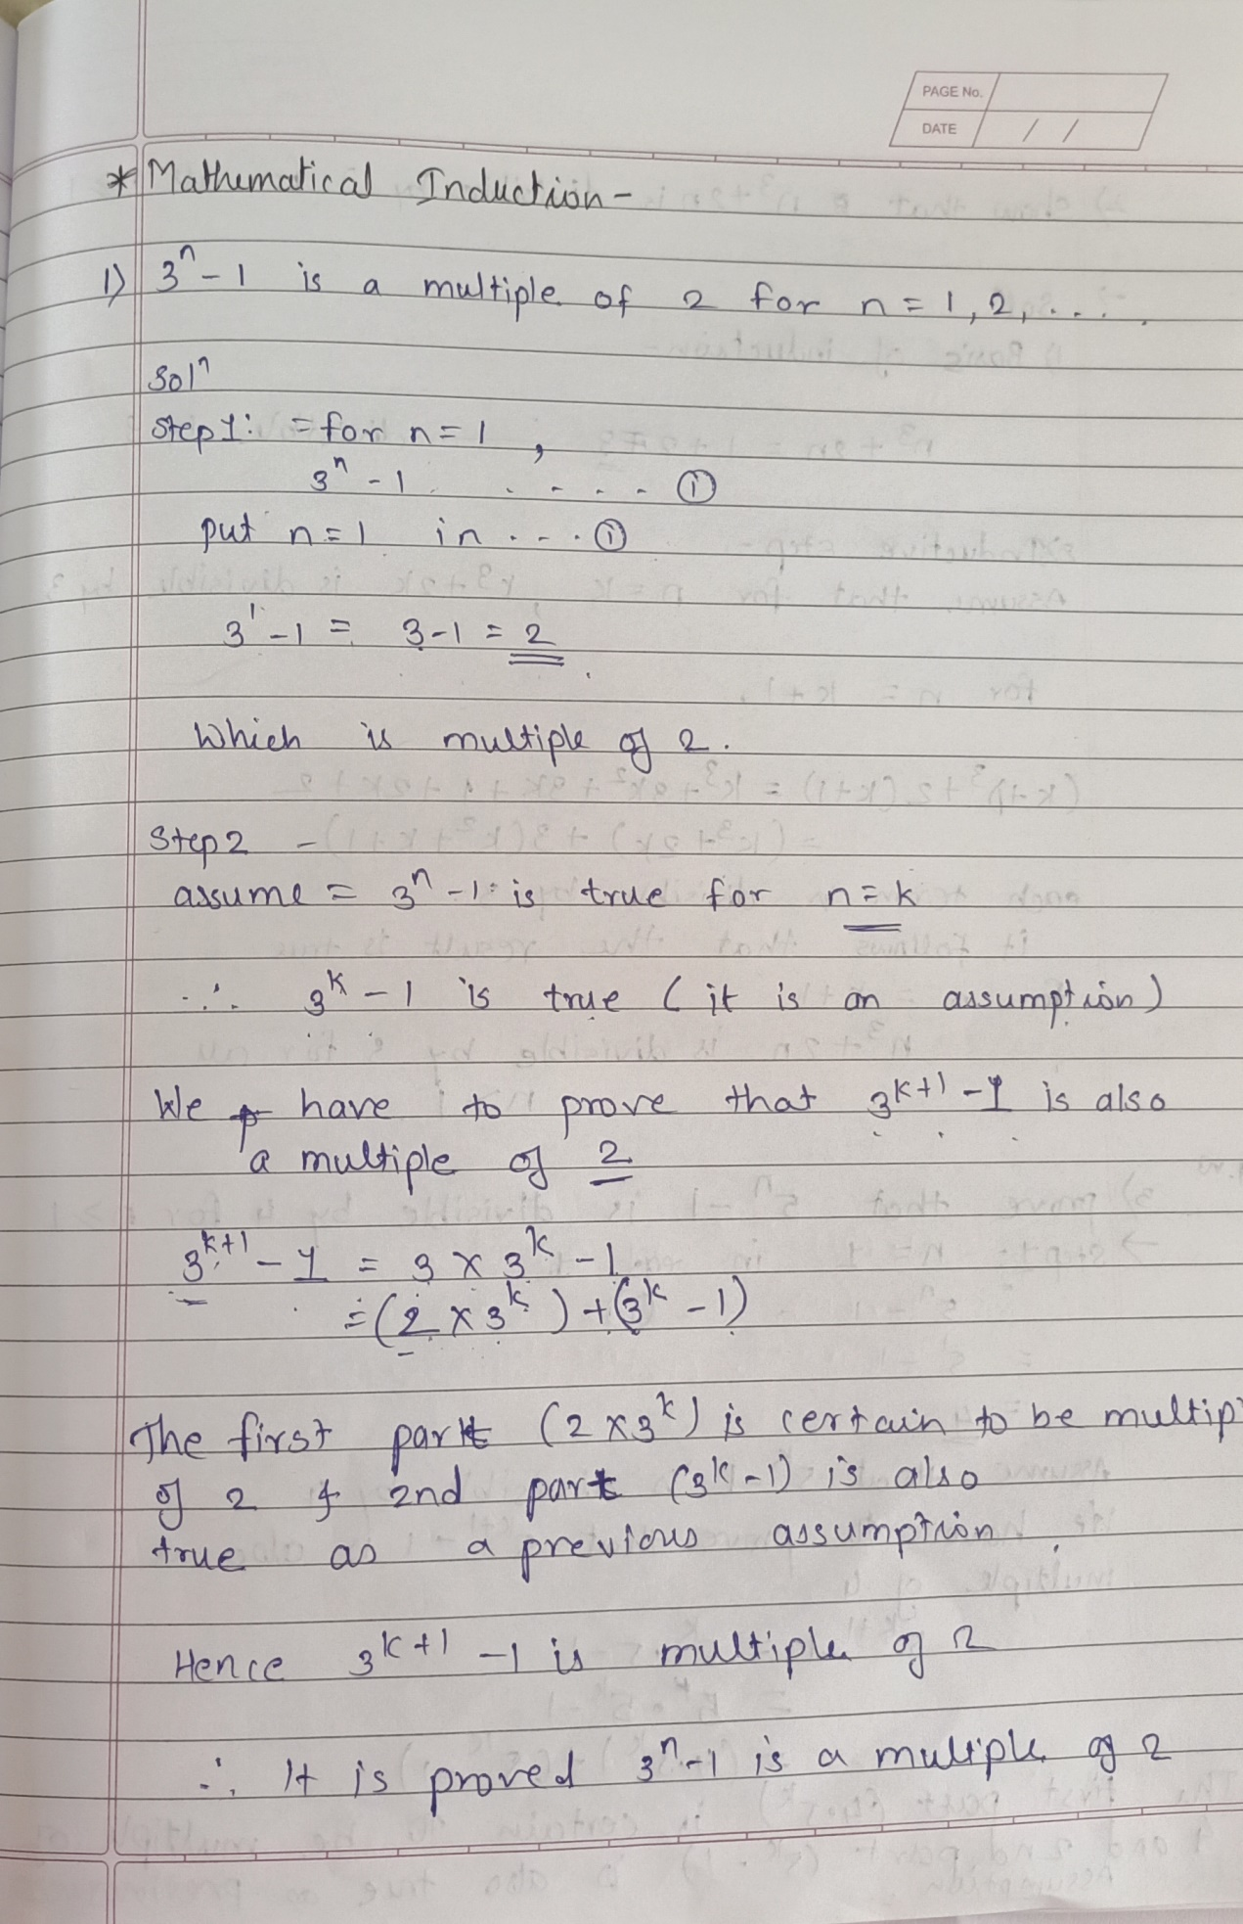

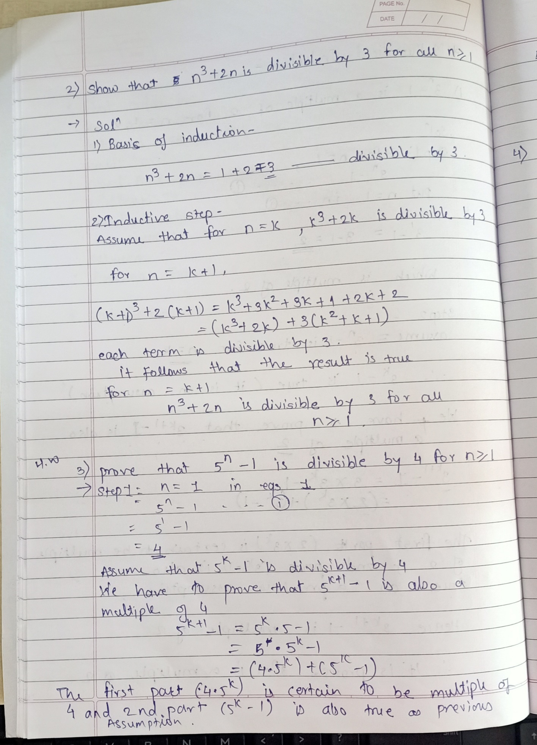

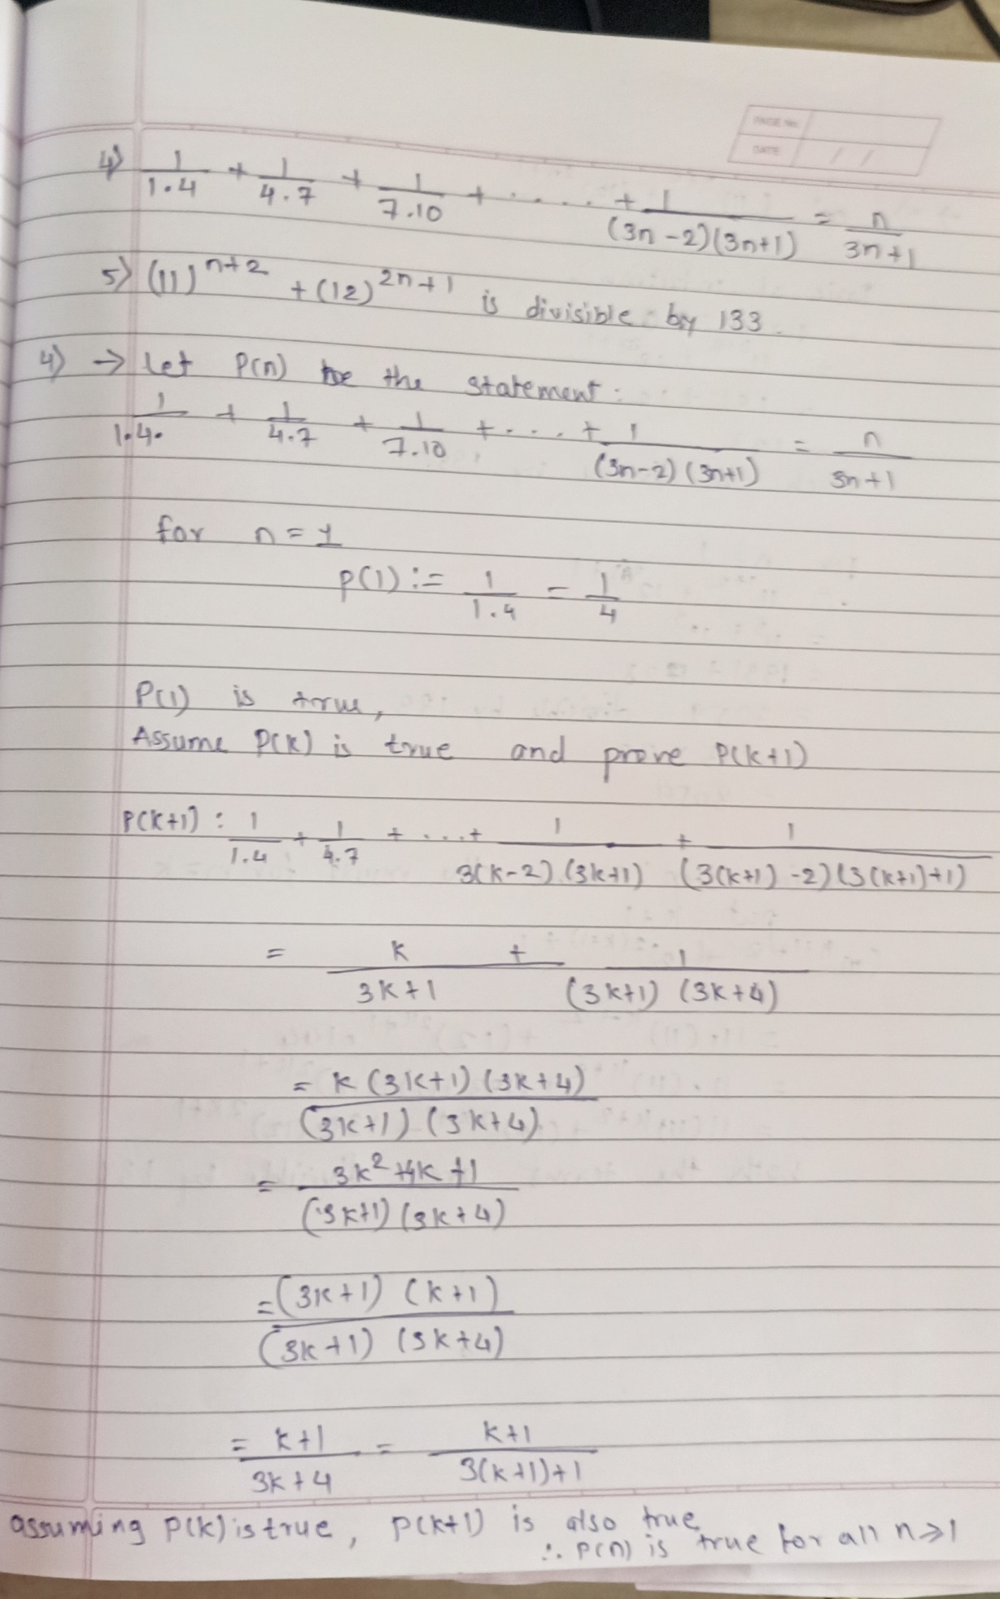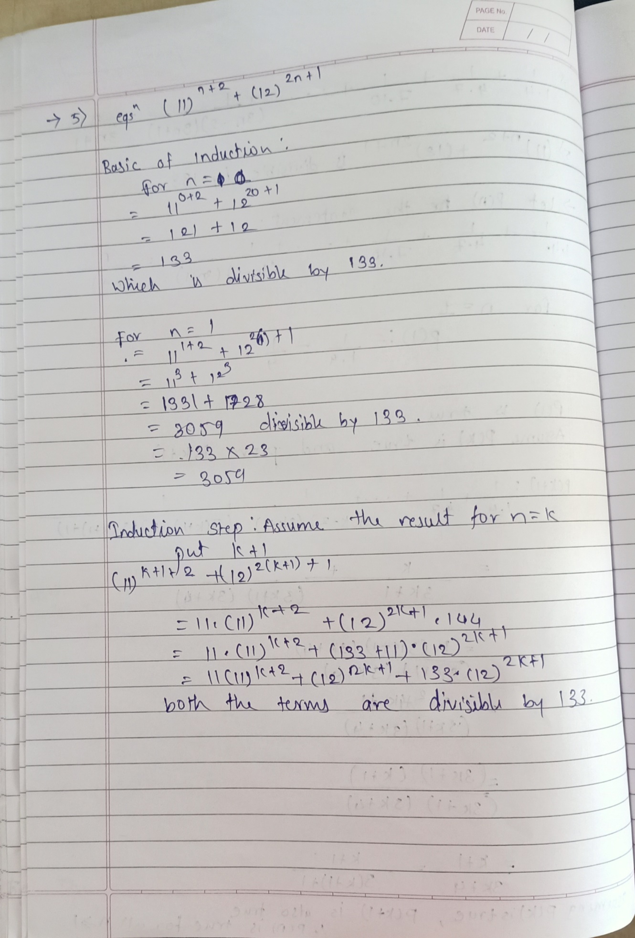

**14.The Well-ordering Principle:**

The **well-ordering principle** is a property of the positive integers which is equivalent to the statement of the principle of mathematical induction. Every nonempty set *S* of non-negative integers contains a least element; there is some integer a*a* in S such that a≤b for all *b*’s belonging.

The well-ordering principle says that the positive integers are **well-ordered.** An **ordered set** is said to be **well-ordered** if each and every nonempty subset has a smallest or least element. So the well-ordering principle is the following statement:

**“Every nonempty subset S of the positive integers has a least element”.**

**15.Recursive definition:**

Sometimes it is possible to define an object (function, sequence, algorithm, structure) in terms of itself. This process is called recursion. Examples:

• Recursive definition of an arithmetic sequence:

– an= a+nd

– an =an-1+d , a0= a

• Recursive definition of a geometric sequence:

• xn= arn

• xn = rxn-1 , x0 =a

**16.Prime Numbers**

A prime number is a positive integer  that has no positive integer divisors other than 1 and  itself. More concisely, a prime number  is a positive integer  having exactly one positive divisor other than 1, meaning it is a number that cannot be factored.

For example, the only divisors of 13 are 1 and 13, making 13 a prime number, while the number 24 has divisors 1, 2, 3, 4, 6, 8, 12, and 24 (corresponding to the factorization ), making 24 *not* a prime number. Positive integers other than 1 which are not prime are called composite numbers.

**What is GCF?**

**GCF** stands for greatest common factor. The greatest common factor of two numbers is the greatest number that is a factor of both of them.

**Finding greatest common factor**

One way to find the GCF of two (or more!) numbers is to list the factors of each number and find the greatest factor they have in common.

**Example:1. GCF of 12and 18**

Factors of 12:  1,2,3,4,6,12

Factors of 18: 1,2 3,6,9,18

1,2,3,6 are common factors of 12 and 18.

Which of these is the greatest?

6 is the greatest factor that 12 and 18 have in common.

gcf(12,18)=6

2. **GCF of 8 and 14**

Factors of 8: 1,2,4,8

Factors of 14: 1,2,7,14

1 and 2 are common factors of 8 and 14.

Which of these is the greatest?

**The greatest common factor of 8 and 14 is 2.**

**17.The Euclidean Algorithm**

The **Euclidean Algorithm** is a technique for quickly finding the **GCD** of two integers.

The Euclidean Algorithm for finding GCD(A,B) is as follows:

1. If A = 0 then GCD(A,B)=B, since the GCD(0,B)=B, and we can stop.
2. If B = 0 then GCD(A,B)=A, since the GCD(A,0)=A, and we can stop.
3. Write A in quotient remainder form **(A = B.Q + R)**
4. Find GCD(B,R) using the Euclidean Algorithm since GCD(A,B) = GCD(B,R)

Example:

1.Find the GCD of 270 and 192

A=270, B=192

A ≠0

B ≠0

Use long division to find that 270/192 = 1 with a remainder of 78. We can write this as: 270 = 192 * 1 +78

2.Find GCD(192,78), since GCD(270,192)=GCD(192,78)

A=192, B=78

A ≠0

B ≠0

Use long division to find that 192/78 = 2 with a remainder of 36. We can write this as:

192 = 78 * 2 + 36

3.Find GCD(78,36), since GCD(192,78)=GCD(78,36)

A=78, B=36

A ≠0

B ≠0

Use long division to find that 78/36 = 2 with a remainder of 6. We can write this as:

78 = 36 * 2 + 6

4.Find GCD(36,6), since GCD(78,36)=GCD(36,6)

A=36, B=6

A ≠0

B ≠0

Use long division to find that 36/6 = 6 with a remainder of 0. We can write this as:

36 = 6 * 6 + 0

5.Find GCD(6,0), since GCD(36,6)=GCD(6,0)

A=6, B=0

A ≠0

B =0, GCD(6,0)=6

**So we have shown:**

GCD(270,192) = GCD(192,78) = GCD(78,36) = GCD(36,6) = GCD(6,0) = 6

**GCD(270,192) = 6**

**18. Fundamental Theorem of Arithmetic**

The fundamental theorem of arithmetic says that "factorization of every composite number can be expressed as a product of primes irrespective of the order in which the prime factors of that respective number occurs". The fundamental theorem of arithmetic is a very useful method to understand the prime factorization of any number.

## Fundamental Theorem of Arithmetic Definition

The statement of the fundamental theorem of [arithmetic](https://www.cuemath.com/numbers/arithmetic/) is: "Every [composite number](https://www.cuemath.com/numbers/composite-numbers/) can be factorized as a product of primes, and this factorization is unique, apart from the order in which the prime factors occur."

For example, let us find the prime factorization of 240.

5

3

2

2

2

2